Designing The Window Of Your Dreams
A Guide
By Gomm Stained Glass, LLC

Step 1 – Research For Your Window Design.

Some people call their file of ideas “scrap.” Flipping through magazines, Pinterest, Pattern Books, Web Sites and Blogs will give you a place to start.
Here’s a link to Our Pattern Books
https://www.gsg-art.com/store-books.html

Now .. get your pencil out, glass patterns are simple lines and curves, so you don’t have to have a fine art degree to sketch a design. Look at photos, calendars or real life to play with your ideas.

You can visit places in your area where stained glass is on display, like the library or a public building, maybe at art shows. Study what you love about the design to help you with your own piece.
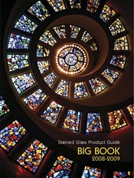

Step 2 – Where Does Stained Glass Go?

Be Creative, Stained Glass looks gorgeous in a window so walk around and see which windows would be good for glass. Or how about hanging a window on your wall? People put windows in their doors and the sidelights next to them and they sometimes hang them on a front porch.
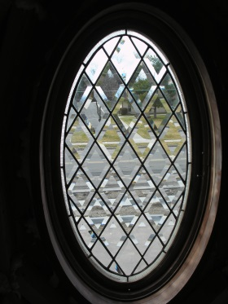
Here’s a list of places to spark your imagination:
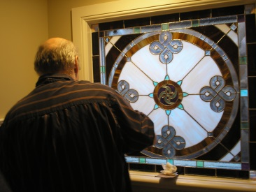
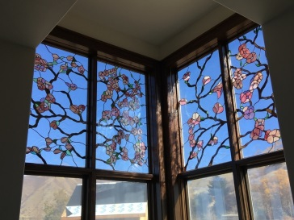
*Hall or Closet Door,
*Sidelights,
*Transoms,
*Bathroom Cabinet,
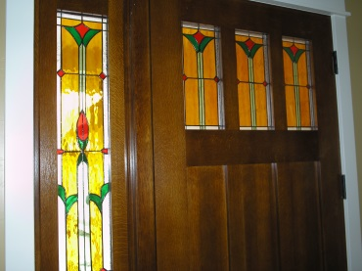
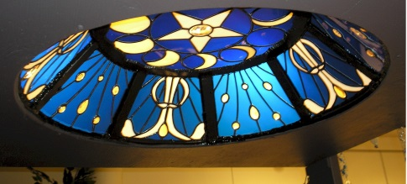
*Room Divider,
*Lamps,
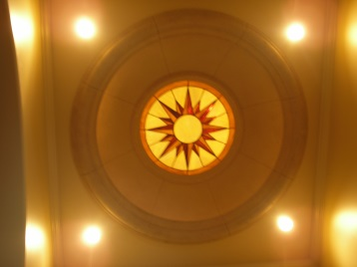
*Picture or Mirror Frames,
*Outdoor Address,
*Spa Windows,
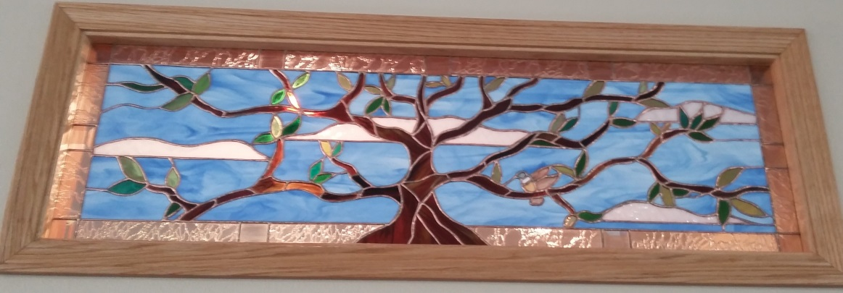
*Skylights
* Kitchen Cabinets

Step 3 – Do I Have A Style?

Ask yourself some questions
- Do I like straight lines or curvy lines?
- Do I lean towards simple or lots of pieces?
- Do I want bright colors or no color at all?
- Do I have personal or family symbols I would like to include?
- Am I more comfortable in a rustic or formal room?
- Is there a particular era that speaks to me?
  - Victorian
  - Edwardian
  - Mission Style
  - Art Nuevo
  - Prarie Style
  - 60’s (See Peter Max)

Step 4 – Work With An Expert

At Gomm Stained Glass we offer:
- Friendly And Helpful Artists
- Experienced (Since 1983)
- Have Built Hundreds Of Windows For Homes And Businesses
- Clients Return Because They Trust Our Work
- We Care About Your Success
- Plans Are Drawn In AutoCAD for a perfect fit

Now Is The Time For Your Dream To Begin,
Take It From Design To Done!

You can register for a FREE 15 minute call with Jeanne Gomm, who will help take you to the next design steps to creating your custom work of art.

The Link Below will help you to schedule your call with Jeanne,
It will take you to a calendar and you can pick the most convenient time for your call. Then you can call at the appointed time and talk to stained glass designer and author, Jeanne Gomm about your Dream Window!

Click Here
(Or Go To vCitaxxx)

Time Is Limited, So Schedule Your Call Now!
(Go To vCitaxxx)

